Luminescent lanthanide complexes as molecular and solid probes.
F. Riobé,*ª A. T. Bui,^{b} M. Hojorat,ª O. Maury.ª
a - Laboratoire de Chimie de l’ENS Lyon, 46 allée d’Italie, 69364 Lyon Cedex 07.
b - Institut des Sciences Chimiques de Rennes, ENSCR, 11 allée de Beaulieu, 35708 Rennes cedex 7.
E-mail: francois.riobe@ens-lyon.fr

Previous works of our team were devoted to the design and the study of highly luminescent species sensitized by two-photon excitation, enabling high-resolution tridimensional imaging of cellular medium.¹ It required the design of a series of π-conjugated antennas and a clear understanding of the whole sensitization pathway till an efficient excitation of lanthanide ions. Recently, this approach was rewarded by the discovery of a new complex which shows a high sensitivity to the neighbouring medium (in particular, its oxygen concentration). It enabled an intracellular mapping of the probe luminescence lifetime demonstrating a possible functional imaging.²
This first results initiated the development of a new class of compounds that could also be sensitive to other biological parameters, such as: temperature, pH, or viscosity. Beyond new luminescent bioprobes for imaging, we also expect that such compounds, among the brightest complexes ever reported,³ could offer applications as precursor for functional materials. Our first attempts on the preparation of colorimetric thermometers will be presented.
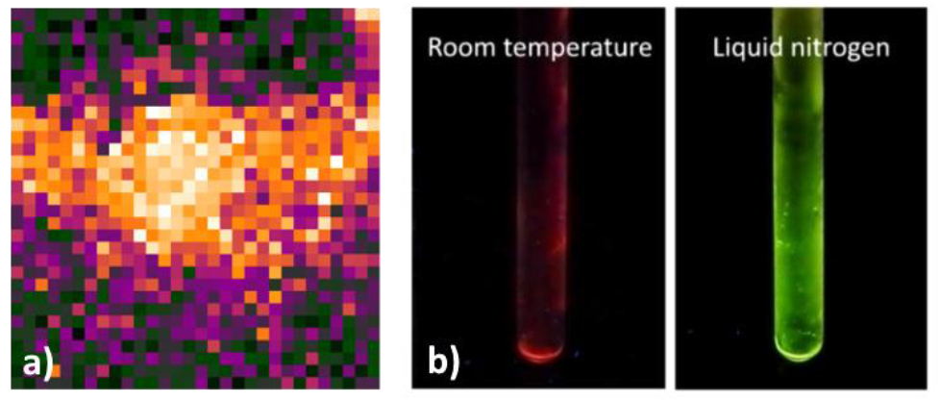
Figure a) mapping of intracellular luminescence lifetime obtained with a terbium complex and b) colour change of a mixture of Eu and Tb complexes at different temperatures.

1 A. T. Bui, M. Beyler, Y.-Y. Liao, A. Grichine, A. Duperray, J.-C. Mulatier, B. L. Guennic, C. Andraud, O. Maury and R. Tripier, Inorg. Chem., 2016, 55, 7020; A. T. Bui, A. Grichine, S. Brasselet, A. Duperray, C. Andraud, O. Maury, Chem. Eur. J., 2015, 21, 17757.
2 A. T. Bui, A. Grichine, A. Duperray, P. Lidon, F. Riobé, C. Andraud, O. Maury, J. Am. Chem. Soc., 2017, 139, 7693.
3 A. T. Bui, A. Roux, A. Grichine, A. Duperray, C. Andraud, O. Maury, Chem. Eur. J., 2018, 24, 3408.

