On The Use of Ruthenium(II) Polypyridil Building Blocks in Linear and non-Linear Optical Systems
Elodie ROUSSET,^{a,b,c} Sylviane CHEVREUX,ª Valérie MARVAUD,^{b} Garry S. HANAN,^{c} Gilles LEMERCIERª

ª Université de Reims Champagne Ardenne, ICMR UMR 7312 BP 1039 – 51687 Reims, France
^{b} Dpt de Chimie, Université de Montréal, 2900 Edouard-Montpetit, Montréal, QC, H3T-1J4,
^{c} UPMC-Sorbonne Université, IPCM UMR 8232, cc 42, 4 pl. Jussieu, 75015 Paris, France.
elodie.rousset@univ-reims.fr

The valuable photophysical properties of the archetypal [Ru(bpy)₃]²⁺, and the tremendous number of its analogues, have no longer to be proven. Our research interest lies in the use of such derivatives as functional subunits to design optically-active complex systems.^{[1]} Based on the linear or nonlinear character of the optical response, a great range of potential applications becomes accessible, from environmental concerns to public health issues. We will address in particular: (i) their use as photosensitizers in supramolecular artificial photosynthesis assemblies where conversion of sunlight and water into H₂ is based on the appropriate combination with other functional subunits as chromophores, and catalysts. ^{[2, 3]} (ii) linear and two photon absorption properties of 5-(fluorenyl)-1,10-phenanthroline based Ru(II) complexes^{[4]} in the perspective of potential applications such as optical power limiting^{[5]} or two-photon excited photodynamic therapy (2PE-PDT).^{[6]}
We will then present one of our approach towards the elaboration and study of related functionalized nanoparticles^{[1]} and more particularly a switch from two-photon absorption of Ru(II) coordination complexes in solution to a saturable absorption phenomena for the related decorated-gold nanoparticles.^{[7]}
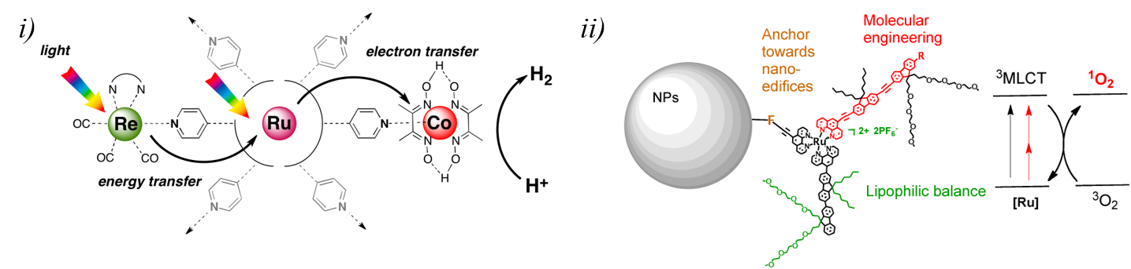
Figure 1 Example of Ru(II) systems developed for i) linear and ii) non-linear optical applications
1. G. Lemercier, M. Four, S. Chevreux, Coord. Chem. Rev., 2018, 368, 1.
2. E. Rousset, D. Chartrand, I. Ciofini, V. Marvaud, G. S. Hanan, Chem. Comm., 2015, 51, 9261.
3. E. Rousset, I. Ciofini, V. Marvaud, G. S. Hanan, Inorg. Chem., 2017, 56(16), 9515.
4. O. Mongin, M. Four, S. Chevreux, M. Blanchard-Desce, G. Lemercier, Chimia, 2015, 69, 666.
5. M. Four, D. Riehl, O. Mongin, M. Blanchard-Desce, L. M. Lawson-Daku, J. Moreau, J. Chauvin, J. A. Delaire, G. Lemercier, PhysChemChemPhys., 2011, 13, 17304.
6. C. Boca, M. Four, A. Bonne, B. van Der Sanden, S. Astilean P. L. Baldeck, G. Lemercier, Chem. Commun., 2009, 4590.
7. J. Moreau, F. Lux, M. Four, J. Olesiak-Banska, K. Matczyszyn, P. Perriat, C. Frochot, P. Arnoux, O. Tillement, M. Samoc, G. Ponterini, S. Roux, G. Lemercier, Phys. Chem. Chem. Phys., 2014, 16,14826.

