Polyoxometalate mediated electron transfer for dye-sensitized transparent semi-conductors
Y.Ben M’barekª, S.Blanchardª, G.Izzetª, F.Volatronª, T.E.Rosser^{b}, M.Chavarot-Kerlidou^{b}
V.Artero^{b}, A.Proust*ª

ª : Sorbonne Université, Institut Parisien de Chimie Moléculaire, UMR 8232,
Pierre et Marie Curie-CNRS, 4 Place Jussieu; 75252 Paris cedex 05
^{b} : Laboratoire de Chimie et Biologie des Métaux, Université Grenoble Alpes, CEA, CNRS, 17 rue des Martyrs 38000 Grenoble, France
*corresponding author e-mail: anna.proust@sorbonne-universite.fr

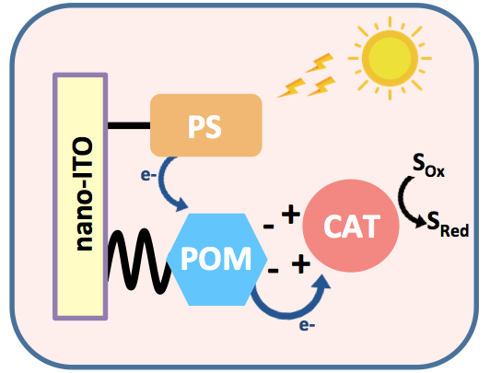
In the context of the ANR Project Photocarb, our goal is to build a photocathode able to reduce CO₂ using solar energy. Therefore, our first challenge is to efficiently convert sunlight into reducing equivalents. Inspired by natural photosynthetic systems, we intend to promote charge separation by electron transfer cascade using polyoxometalates (POMs), since these compounds are known for their electron-accepting properties¹.
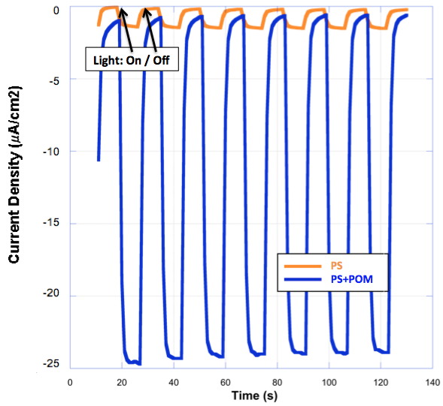
To do so, we developed photocathodes through the co-grafting of a photosensitizer² (PS) and a POM hybrid³ onto transparent semiconductors. Preliminary results will be presented, showing the contribution of POMs as electron mediators able to enhance the photo-generated current in the presence of a sacrificial electron acceptor.

PS vs PS+POM photocurrent

¹ : M. Sadakane, E. Stechkan, Chem. Rev. 1998, 98, 219−237
² : J. Massin, M. Bräutigam, N. Kaeffer, N. Queyriaux, F. H. Schacher, J. Popp, M. Chavarot-Kerlidou, B. Dietzek V. Artero, Interface Focus, 2015, 5, 20140083
³ : G. Izzet, F. Volatron, A. Proust, Chem. Rec. 2017, 17, 250 – 266

