New multi-dimensional oxamate-based architectures and their magnetic properties
Ang Li,ª Yves Journauxª*, Laurent Lisnardª, Lise-Marie Chamoreauª, Benoit Baptiste^{b}, Geoffrey Gontardª, Jérémy Fortéª, Yanling Liª
a. Sorbonne Université, CNRS, Institut Parisien de Chimie Moléculaire, IPCM, F-75252, Paris, France.
b. Sorbonne Université, CNRS, Institut de Minéralogie, de Physique des Matériaux et de Cosmochimie, IMPMC, F-75252, Paris, France.
Corresponding author e-mail address: Yves.Journaux@sorbonne-universite.fr

Design and synthesis of multifunctional magnetic coordination polymers (MMCPs) lies in the interdisciplinary crossing point between chemistry, physics and material science and attracts a large number of research teams due to their potential applications in nanoscience¹. The family of N-substituted aromatic oxamate ligands are considered as ideal candidates for obtaining structure with predictable dimensionality and magnetic properties², and classical oxamate-based multidimensional compounds are mainly synthesized following a bis-bidentate ‘complex as ligand’ synthetic strategy. In order to change this type of coordination modes and obtain novel MMCPs, we have introduced additional coordination groups (hydroxyl and carboxylic acid) as para-substituted polytopic oxamate ligands. The 2D hetero-metallic compound {(TMA)₃[Cu(paba)₂Mn(CH₃COO)(H₂O)(DMF)]}_{n}, 3D homo-metallic compounds [Mn(Hpaba)H₂O] and (TMA)[Cu(paba)], and 3D hetero-metallic compound (TMA)₂[Cu(paba)₂Mn₂(ox)](DMF)₂ (H₃paba= 4-oxamatobenzoic acid) were successfully synthesized using solvothermal methods, which were seldom explored in oxamate chemistry. Interestingly magnetic ordering is observed for the hetero-metallic 2D and 3D compounds, supporting the potential of our approach for preparation of MMCPs.
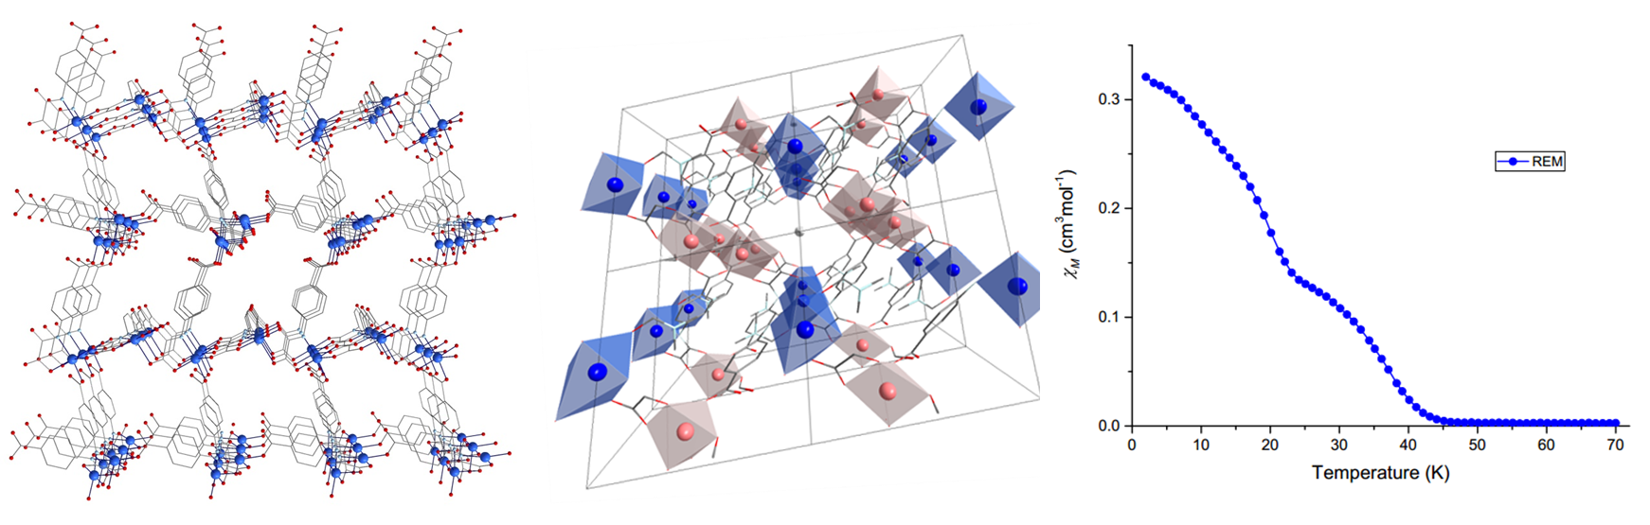
c
b
a
Figure 1 Perspective view of oxamate-based 3D Cu based compounds (a) and Cu-Mn based compounds (b) together with its remanence curve (c)
1 A. Y. Robin, K. M. Fromm, Coord. Chem. Rev., 2006, 250, 2127.
2 Y. Journaux, J. Ferrando-Soria, E. Pardo, R. Ruiz-Garcia, M. Julve, F. Lloret, J. Cano, Y. Li, L. Lisnard, P. Yu, H. Stumpf, C. L. M. Pereira, Eur. J. Inorg. Chem., 2018, 2018, 228.

