Hybrid Quantum Dots: Conversation between a Nanocrystal and a Coordination Complex
M. Fuchs,ª B. Fleury*,ª M. Giraud,^{b} C. Chanéac,^{c} E. Freysz,^{d} J. von Bardeleben,^{e} J.-L. Cantin^{e}
ª Sorbonne Université, CNRS, IPCM, 75005 Paris, ^{b} Université Paris Diderot, CNRS, ITODYS, 75013 Paris, ^{c} Sorbonne Université, CNRS, Collège de France, LCMCP, F75005 Paris, ^{d} Université de Bordeaux, CNRS, LOMA, 33405 Talence, ^{e} Sorbonne Université, CNRS, INSP, 75005 Paris
benoit.fleury@sorbonne-universite.fr

Quantum dots (QDs) are of great interest thanks to their unique optical properties coming from the quantum confinement of their photo-induced exciton.
Based on an easy synthesis of CdSe QDs developed by Qu et al.¹, we propose to study the coupling of the exciton with a transition metal of coordination complexes grafted on the surface of these nanoparticles. These Hybrid QDs (HQDs) aim to circumvent issues of the doping (random doping concentrations, excretion, empty particles) previously developed by Gamelin et al.^{2,3,4}.
We describe here the work made on the synthesis of the nanocrystal core, the design of the complexes grafted on the surface of the core and the surface chemistry involved in the formation of the HQDs systems (Figure 1).
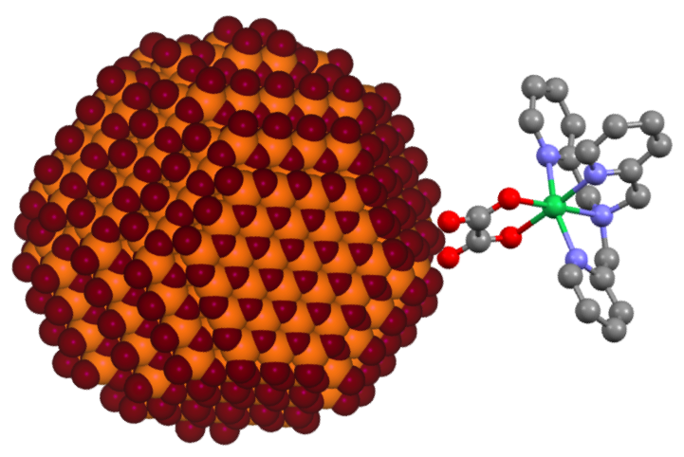
Figure 1 Structure of a HQD of CdSe@[Ni(ox)(tpma)]

1 L. Qu, X. Peng, J. Am. Chem. Soc., 2002, 124, 2049.
2 R. Beaulac, Y. Feng, J. W. May, E. Badaeva, D. R. Gamelin, X. Li, Phys. Rev., 2011, 84, 195324.
3 R. Beaulac, L. Schneider, P. I. Archer, G. Bacher, D. R. Gamelin, Phys Rev, 2009, 325, 973.
4 R. Beaulac, P. I. Archer, S. T. Ochsenbein, D. R. Gamelin, Adv. Funct. Mater., 2008, 18, 3873.

